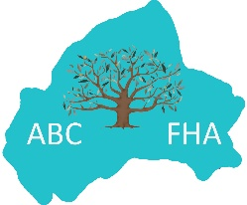
ABC Family History Association
Corporate Membership Application Form

You may complete this form online in Word, save it with your organisation name attached and email it to abcfhamem@gmail.com or print it out and post it to:
ABCFHA, c/o 7 Moygannon Road, Donaghcloney, Craigavon, Co Armagh BT66 7NB

Name of Organisation: Click or tap here to enter text.
Address of Organisation: Click or tap here to enter text.

You may nominate ONE representative to attend events and receive information/publications:

Rep 1 Forename: Click or tap here to enter text. Rep 1 Surname: Click or tap here to enter text.

Rep 1 Address: Click or tap here to enter text.

Rep 1 Email address: Click or tap here to enter text. Rep 1 Phone: Click or tap here to enter text.

Please tell us why you want to join our Association: Click or tap here to enter text.
Please do NOT send any fees at this time. If your membership is accepted, we will send you a membership pack with details of how and when to pay your membership fee.

