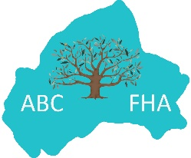
ABC Family History Association
Membership Application Form
(for Full, Online, Joint and Student Membership)
You may complete this form in Word, save it with your surname attached and email it to abcfhasec@gmail.com or print it out and post it to:
ABCFHA Sec, c/o 7 Moygannon Road, Donaghcloney, Craigavon, Co Armagh BT66 7NB

Type of Membership: Full ☐ Online ☐ Joint ☐ Student ☐

Adult 1 Forename: Click or tap here to enter text. Adult 1 Surname: Click or tap here to enter text.
Address: Click or tap here to enter text.

Email address: Click or tap here to enter text. Phone: Click or tap here to enter text.

Joint Members only – Details of Second Family Member at this address
Adult 2 Forename: Click or tap here to enter text. Adult 2 Surname: Click or tap here to enter text.
Email address: Click or tap here to enter text. Phone: Click or tap here to enter text.

Student Member only: Are you a FT Student? Choose an item.
Where are you studying? Click or tap here to enter text.
Are you aged 18 years or over? Choose an item.

All members: Please tell us why you want to join our Association: Click or tap here to enter text.
Please do NOT send any fees at this time. If your membership is accepted, we will send you a membership pack with details of how and when to pay your membership fee.

